CS580K - Cloud Computing Big Project

Live Video Streaming and Chat Web Application using Google Docker and Kubernetes

By

Bhanu Dobriyal

Tejesh Agrawal

Kasturi Vartak

**Index**

1. Abstract
2. Motivation
3. Web Interface

3.1 Video and Chat Interface

3.2 Integration

1. Docker

4.1 Packaging the app as a container

4.2 Running the container

4.3 Uploading container image to Docker Hub

1. Deploying app to Kubernetes cluster
2. Autoscaling using Kubernetes
3. How to use this application
4. Challenges
5. Future Scope
6. Links
7. References
8. **Abstract**

* Created a Web Application with live Video and Chat features among users
* Build the Docker Image for the single container containing this app
* Uploaded this Image to Docker Hub
* Created cluster using Kubernetes cluster manager
* Deployed the containerized application over Kubernetes cluster
* Autoscaling the app using Kubernetes

1. **Motivation**

**Live streaming video and chat feature**

* Users can share a live video streaming and others can discuss about it over chat
* Similar to various live video streaming by Youtube , Facebook and Instagram
* Large user base and live streaming needs robust platform to orchestrate traffic
* Global video streaming market is 42.6 billion USD as of 2019

**Kubernetes**

* Use Kubernetes deployments to deploy pod workloads
* Allow applications to automatically respond to changes in their workloads and scale to meet demand

1. **Web Interface**

**3.1 Video and Chat Interface**

A key feature of our web application. We wanted to have live video streaming in our application , as this is a real time event generation media and would be a great example to study and understand the performance and behavior of our Cloud computing.

We studied various API documents like Facebook , Youtube and Google for their live video streaming but found challenges in their implementation to use their services for our application development.

Finally we were able to implement this feature using this capability by studying a WebRTC which adds real-time communication capabilities to an application. For the chat feature we used express.js framework to make use of the server, in responses from the client side which we developed using ejs engine and various javascript files to use socket.io library for making connections to server and render it over client side.

Below is the web architecture of the application.

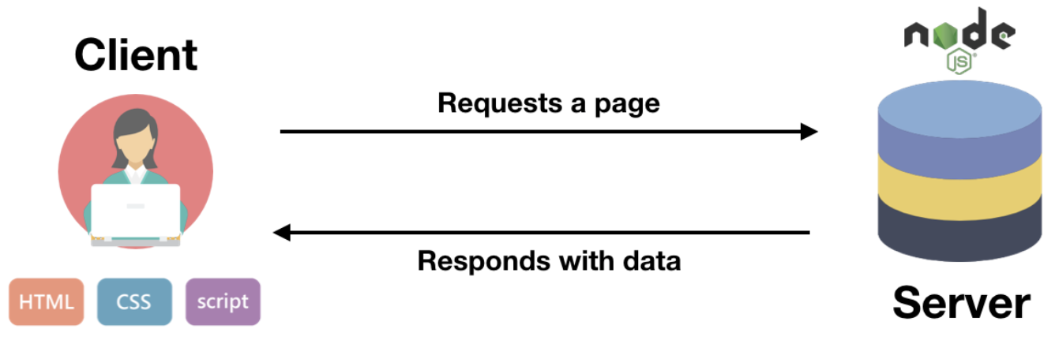

Below is the technical stack used for this app.

* **Ejs** - template engine to simplify production of HTML
* **Websockets** - Protocol that allows bilateral synchronous exchange

between client and server. Socket.io is the library used.

* **Express.js** - Framework based on Node.js which is JS back-end tech executed by server.
* **CSS** - For user interface template design and stylesheets.

Below is the file structure of the code of our application.

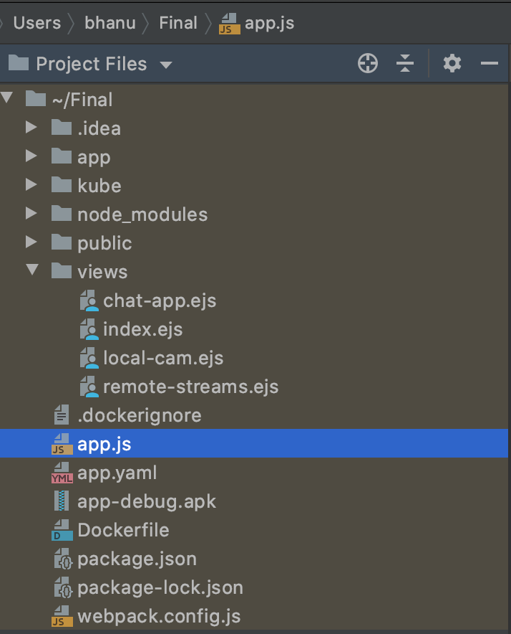

**3.2 Integration**

As these features are completely different from a user perspective , it required efforts to integrate it over one system in terms of real time connections across multiple users synchronously on the same server.

1. **Docker**

**4.1 Packaging the app as a container**

* In this we need to package and run the application using Linux and Docker containers by using mechanism to encapsulate apps with all of their dependencies into a single archive
* To run the app, we only need the archive.
* With Linux containers, you can start the application even if you don't have Node.js installed.
* First we need to install the Docker Community Edition (CE).
* You can do this by referring to the below link.

<https://docs.docker.com/get-docker/>

$ git clone https://github.com/waft-media-corp/waaft.git

* Docker containers are built from Dockerfile

$vi Dockerfile

FROM node:12.0-slim

COPY . .

RUN npm install

CMD [ "node", "app.js" ]

Where,

* FROM defines the base layer for the container, in this case, a version of Ubuntu with Node.js installed
* COPY copies the files of your app into the container
* RUN executes npm install inside the container
* CMD defines the command that should be executed when the container starts

Then we have run the below command in terminal

$ docker build -t waaft .

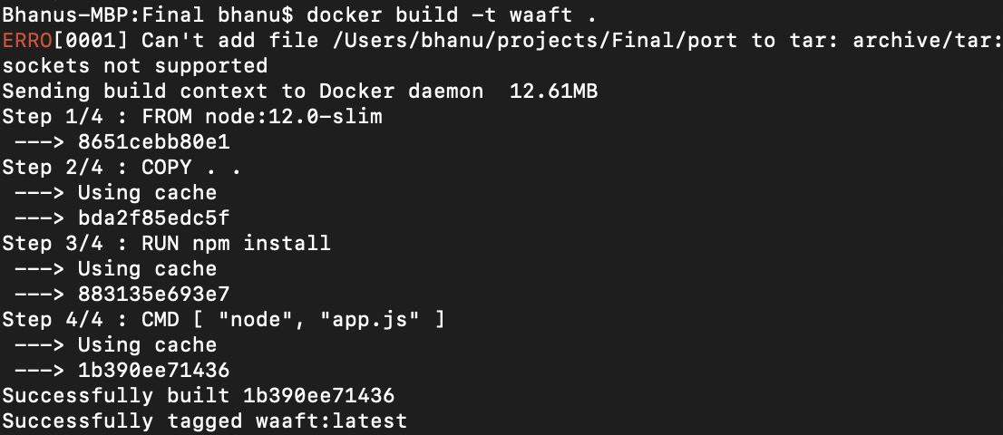

**4.2 Building the container**

* Build a container image from our app with command:

$ docker build -t waaft .

-t waaft → defines the name ("tag") of your container

. → is the location of the Dockerfile and application code — in this

case, it's the current directory

The command executes the steps outlined in the Dockerfile, one

by one

Output is a Docker image.

* A Docker image is an archive containing all the files that are packaged in a container.

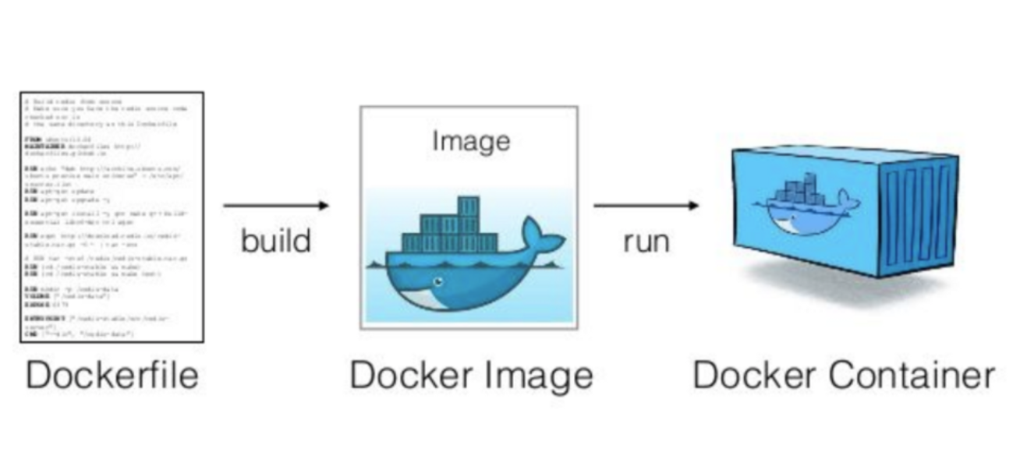

List docker images:

$ docker images

**4.3 Uploading container image to Docker Hub**

To ensure this container image can be used by anyone , we can push this image over Docker Hub.

* Access Docker Hub

$docker login

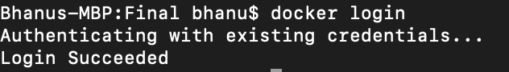

//authenticate and login to docker hub

* Images uploaded to Docker Hub must have a name of the form username/image:tag:

To rename your image according to this format, run the following command:

$ docker tag waft waaft/waaft:3.0.0

Waaft → organization name

Waaft → image name with version 3.0.0

* Upload waft image to Docker Hub

$ docker push waaft/waaft:3.0.0

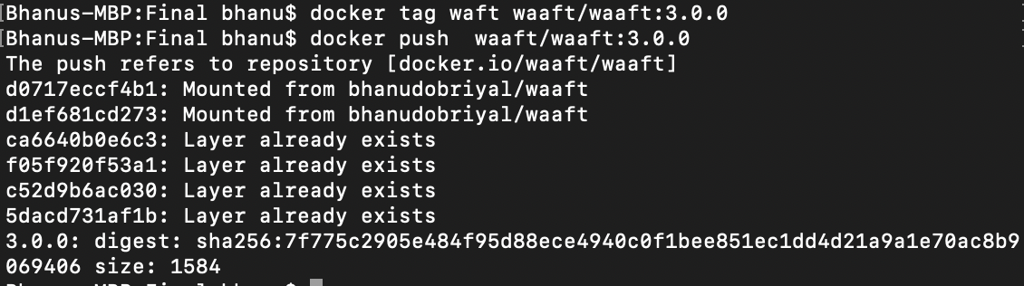

* Now, the image is now publicly available as waaft/waaft:3.0.0 on Docker Hub.

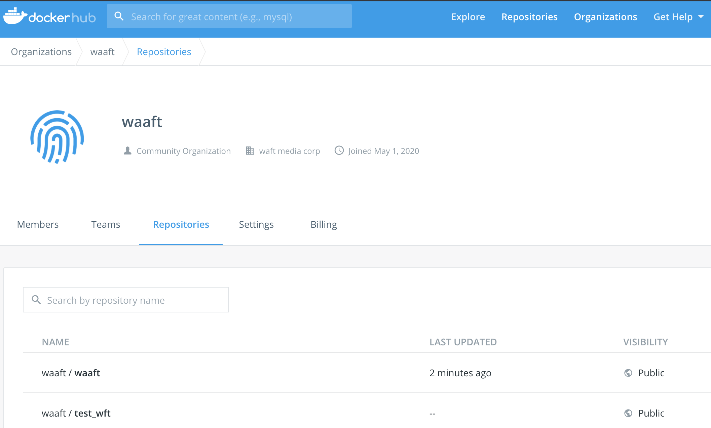

**5. Deploying app to Kubernetes cluster**

$gcloud init

* To launch an interactive Getting Started workflow for the gcloud command-line tool.

$gcloud container clusters create waaftcluster

waaftcluster→ name of cluster

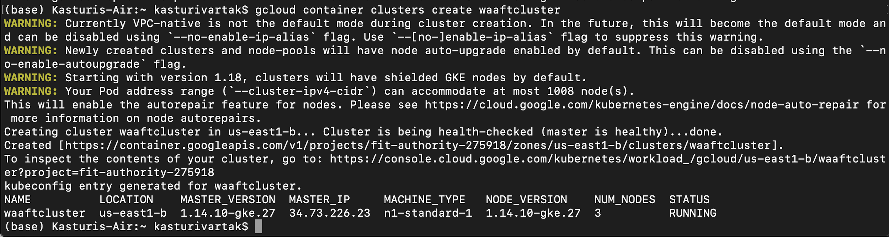

* To connect to a created cluster via command line:

Go to Kubernetes Engine→ Clusters → Connect 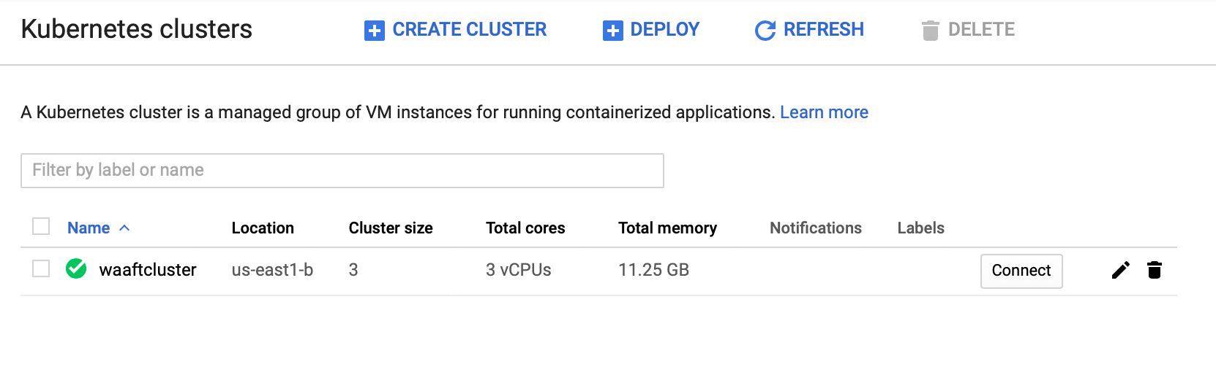

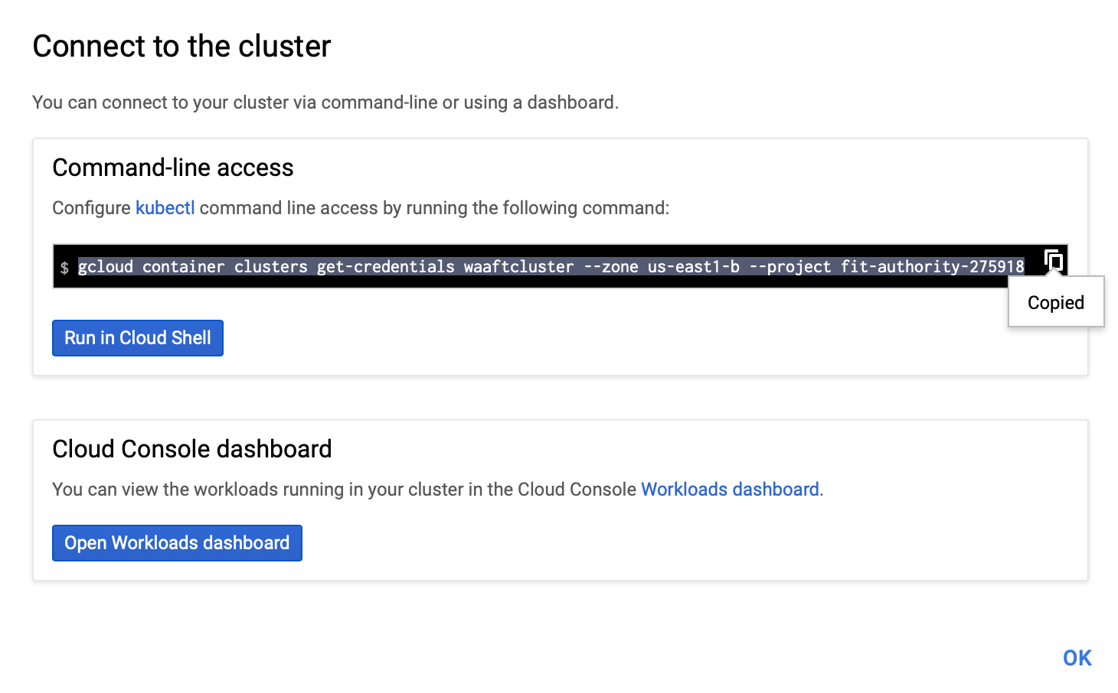

(base) Kasturis-Air:~ kasturivartak$ gcloud container clusters get-credentials waaftcluster --zone us-east1-b --project fit-authority-275918

Fetching cluster endpoint and auth data.

kubeconfig entry generated for waaftcluster.

vim deployment.yaml

(base) Kasturis-Air:~ kasturivartak$ kubectl apply -f deployment.yaml

deployment.apps/waaft created

(base) Kasturis-Air:~ kasturivartak$ kubectl apply -f service.yaml

service/waaft created

**6. Autoscaling using Kubernetes**

We are using horizontal pod scaling to autoscale our application, suppose if the CPU utilization goes beyond 60 %, the pod replicas will increase by 1, we initialized a range for our replicas, min =1 and max =10.

When CPU utilization falls below 60%, then the autoscaler will adjust the replica

count of the targeted deployment down;

When it goes above 60%, replicas will be added

**Script for using the above conditions:**

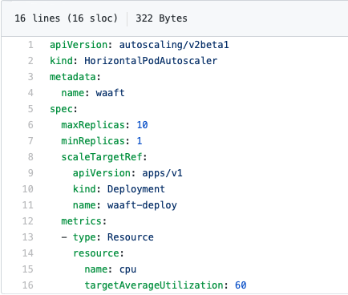

(base) Kasturis-Air:~ kasturivartak$ kubectl apply -f hpa.yaml

horizontalpodautoscaler.autoscaling/kubecluster created

(base) Kasturis-Air:~ kasturivartak$ kubectl describe hpa

After describing hpa, we can see before running application CPU utilization is 1%

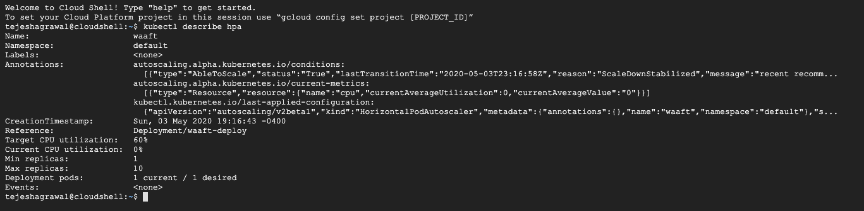

Once, we start the application, the CPU utilization gets increased by 1%. And now it is 1% from 0%.

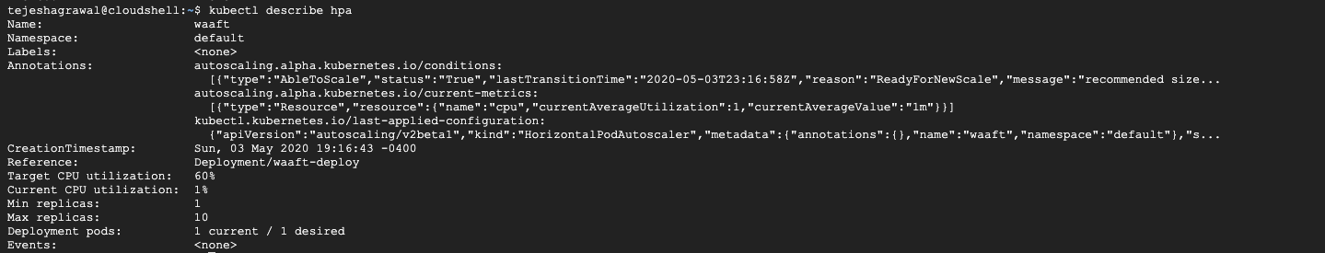

**7. How to use this application**

1. Open the static url given in the Links section on Chrome.
2. In a separate tab in chrome run the following in the URL section.

**chrome://flags/#unsafely-treat-insecure-origin-as-secure**

1. This would provide for the necessary accesses so that the Camera of the system between the peers can work. Click on enable thereafter.

Then click on Relaunch.

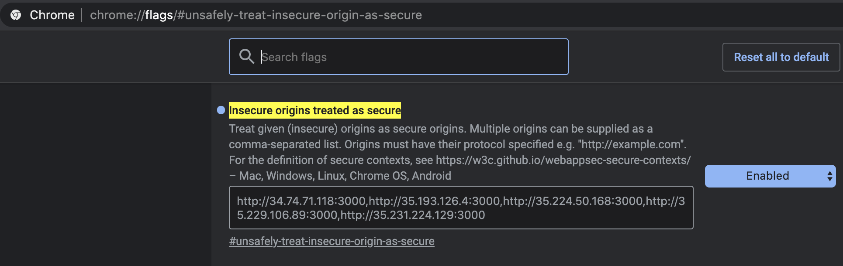

1. After putting url in the browser:

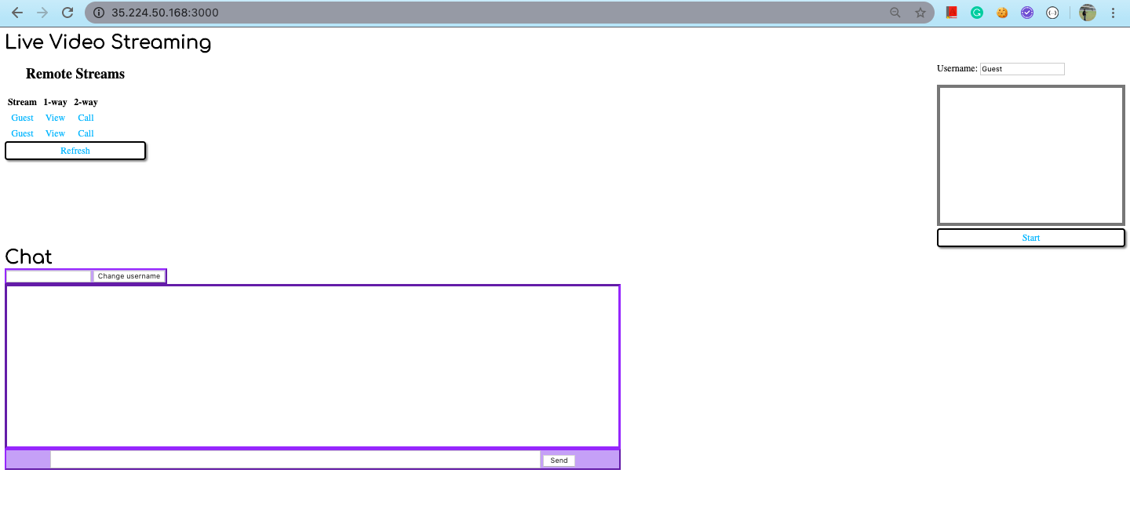

1. After we click on Start, and clicking refresh will give a sharing link.

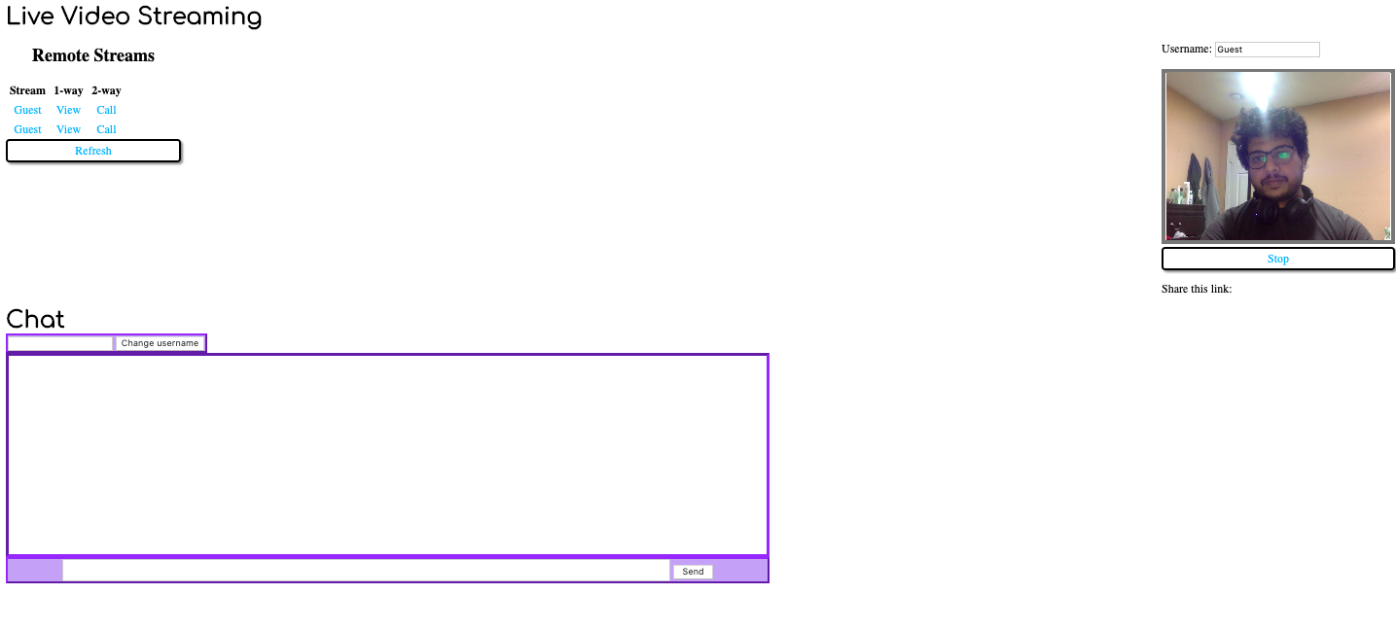

1. Shared link will be joined by the receiver end. Here we can see that we even chat with the peer synchronously as we video stream.

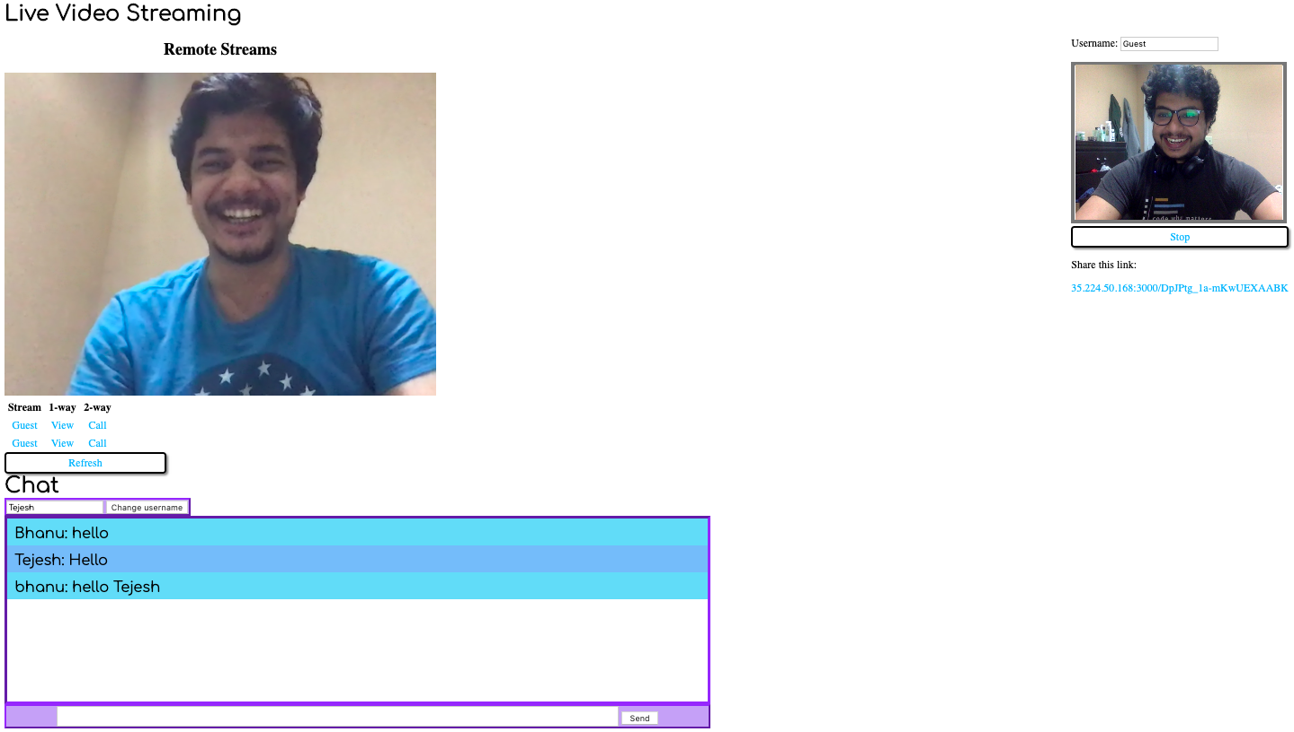

1. We can use this with multiple users as well. Below is the screenshot of our team members using the application for demo. 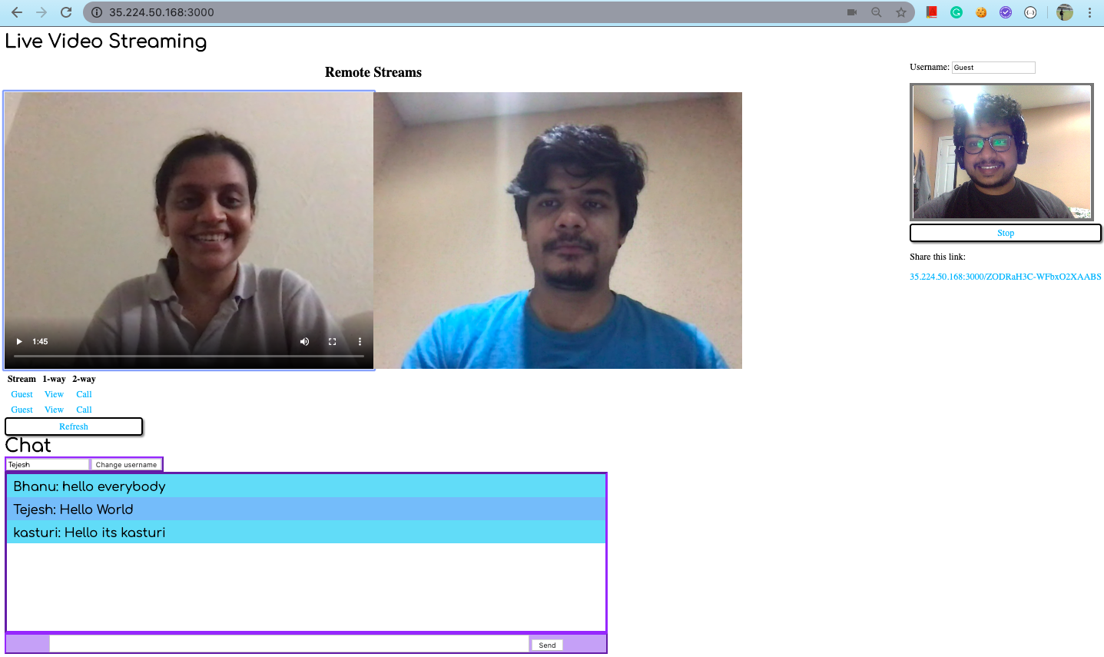

**8. Challenges**

* Instead of Youtube API live streaming, we decided to go and study ffmpeg for camera access, libx24 to encode the live camera video to a format (.avi) video to display on browser, because the video will be hosted on youtube platform, but later we decided to move to WebRTC.
* Instead of nginx, we are currently hosting applications on Kubernetes.Before this we hosted the application directly on GCP app engine, but it consumes GCP credits very fast. So we moved it to Kubernetes cluster and autoscaled it based on CPU utilization.
* Challenges while integrating the Chat and Video features of the application.
* We tried to integrate this application with a login page which uses MongoDb but couldn’t implement it as it provided challenges for the runnability of this application ,as it used the same port number to hit the server.

**9. Future Scope**

* Https, to access the camera on browser, we have to create SSL certificates, for now a user has to manually enable connection for a given url to enable camera through browser.
* Login and Signup pages for authenticating users accessing the feeds. MongoDB connectivity to store this information at backend.
* We will introduce Nginx as well, so that different images such as mongoDB and application docker image can be combined and hosted on a single url.

**10. Links**

**Static Link:**

<http://35.224.50.168:3000/>

**11. References**

**WebRTC:**

<https://webrtc.org>

https://medium.com/@noufel.gouirhate/build-a-simple-chat-app-with-node-js-and-socket-io-ea716c093088

**Kubernetes:**

<https://learnk8s.io/nodejs-kubernetes-guide>

**Autoscaling:** <https://hub.packtpub.com/implementing-horizontal-pod-autoscaling-in-kubernetes-tutorial/>